### Laurel and Litzow age-0 index

Beach seine sampling of age-0 cod was conducted at two Kodiak Island bays during 2006-2023 (n = 8 fixed stations per bay, 16 total stations, stations sampled 4 times per year) and an expanded survey was conducted since 2018 at 13 additional bays on Kodiak Island, the Alaska Peninsula, and the Shumagin Islands (n = 3 - 9 fixed stations per bay, 95 total stations, stations sampled 1 – 2 time per year). Sampling occurred during July and August (days of year 184-240), within two hours of a minus tide at the long-term Kodiak sites, and within three hours of a low tide at the expanded survey sites. At all sites, a 36 m long, negatively buoyant beach seine was deployed from a boat and pulled to shore by two people standing a fixed distance apart on shore. Wings on the seine (13 mm mesh) were 1 m deep at the ends and 2.25 m in the middle with a 5 mm delta mesh cod end bag. The seine wings were attached to 25 m ropes for deployment and retrieval from shore. The seine was set parallel to and ~ 25 m, making the effective sampling area ~ 900 m 2 of bottom habitat.

A model-based index of annual catch per unit effort (CPUE) for age-0 cod was used to resolve inter-annual differences in sampling across different bays and different days of the year. Specifically, a Bayesian zero-inflated negative binomial (ZINB) model was used invoking year as a categorical variable, day of year as a continuous variable, and site nested within bay as a group-level (random) effect. The day of year effect was modeled with thin plate regression splines to account for non-linear changes in abundance through the season and the number of basis functions was limited to 3 to avoid over-fitting data. This model was fit using Stan 2.21.0, R 4.0.2 and the *brms* package (Carpenter *et al.* 2017, Buerkner 2017, R Core Team 2022). The beach seine age-0 CPUE index showed the large 2012 year class and subsequent drop in CPUE for 2013-2016, and since 2016 there have been alternative small recruitment in 2019, 2021, and 2023 with larger recruitment in 2017, 2018, 2020, and 2022 (Table 2.11 and Fig. 2.24).

##### Table 2.11. Age-0 Pacific cod beach seine index (number/haul) and CVs.

|  |  |  |
| --- | --- | --- |
| **Year** | **Number/haul** | **CV** |
| 2006 | 131.44 | 0.29 |
| 2007 | 8.83 | 0.36 |
| 2008 | 32.61 | 0.33 |
| 2009 | 33.25 | 0.5 |
| 2010 | 13.55 | 0.49 |
| 2011 | 36.11 | 0.37 |
| 2012 | 221.21 | 0.33 |
| 2013 | 8.58 | 0.37 |
| 2014 | 9.44 | 0.5 |
| 2015 | 1.29 | 0.91 |
| 2016 | 2.14 | 0.46 |
| 2017 | 85.75 | 0.3 |
| 2018 | 110.03 | 0.21 |
| 2019 | 2.39 | 0.54 |
| 2020 | 204.59 | 0.26 |
| 2021 | 22.4 | 0.25 |
| 2022 | 126.59 | 0.26 |
| 2023 | 34.78 | 0.25 |

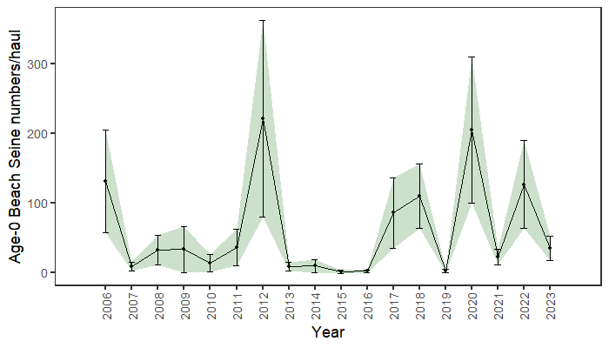

##### Figure 2.24. Age-0 beach seine survey numbers per haul, bars and shading indicate the 95th percentile confidence intervals.